**Guidelines for Photographing and Describing a Building**

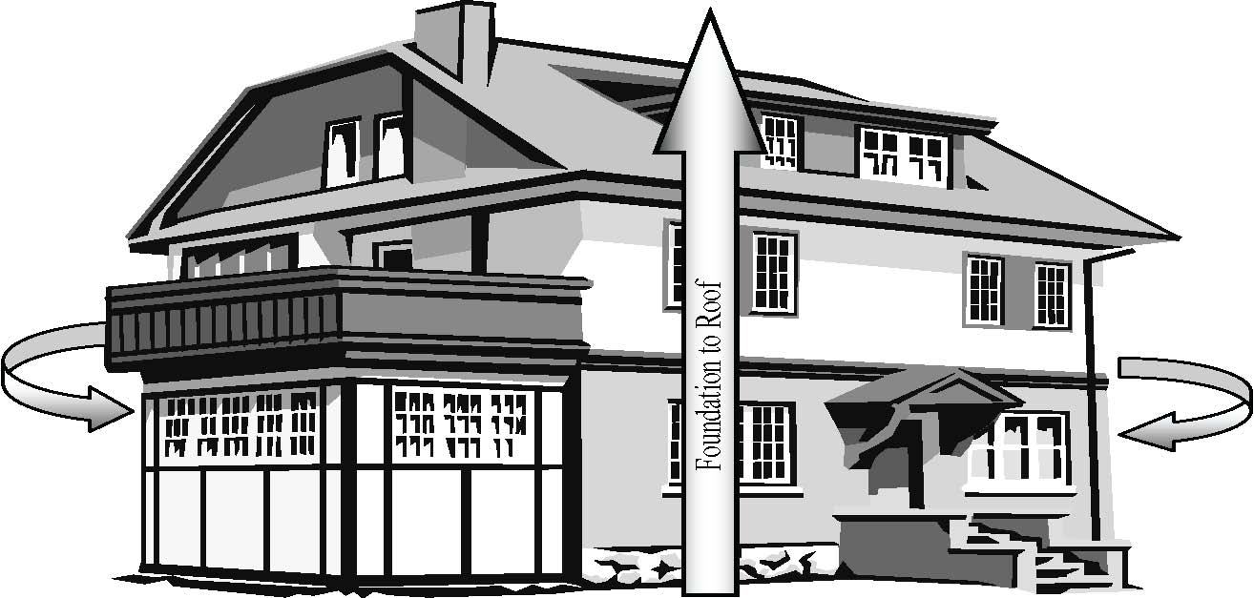

Photo tip:Photographs should be a ¾ shot, getting two elevation of the building in the frame. All elevations must be photographed and must include the whole building, especially the roof, in the frame. Photos for districts should include streetscape shots.

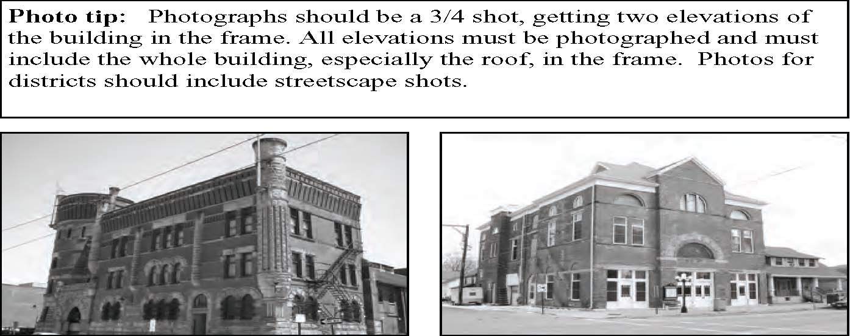

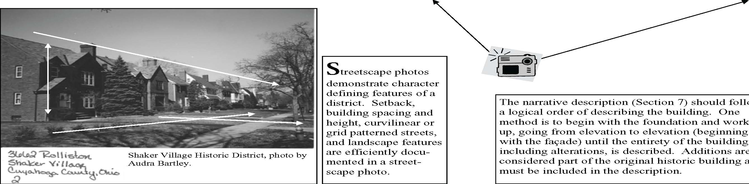

**S**treetscape photos demonstrate character defining features of a district. Setback, building spacing and height, curvilinear or grid patterned streets, and landscape features are efficiently documented in a streetscape photo.

Cleveland Grays Armory, Cleveland Ohio (left) and Jamestown Opera House, Jamestown, Ohio. Photos by Lisa Rupple

**T**he narrative description (Section 7) should follow a logical order of describing the building. One method is to begin with the foundation and work up, going from elevation to elevation (beginning with the façade) until the entirety of the building, including alterations, is described. Additions are considered part of the original historic building and must be included in the description.